**Quarkus and Kafka**

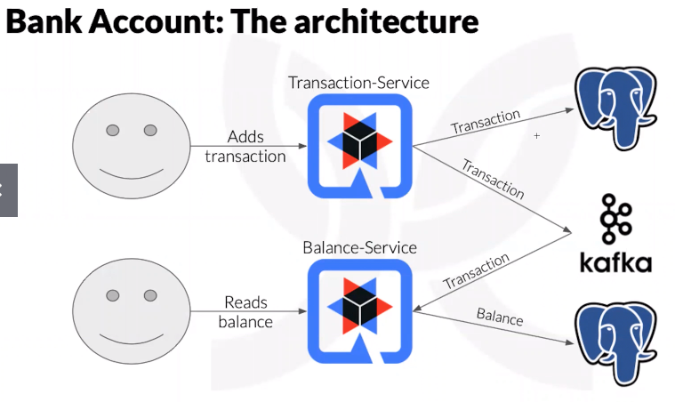

**Deploying the external services**

docker-compose up -d --build

It will deploy four docker containers on your environment with MongoDB, PostgreSQL, Kafka and Zookepper (required by Kafka)

After deploying Kafka, you'll need to [create the topic on the Kafka cluster](https://kafka.apache.org/quickstart). For example:

docker exec -it bankaccount-kafka \

./bin/kafka-topics.sh --create \

--topic transactions \

--zookeeper bankaccount-zookeeper:2181 \

--replication-factor 1 \

--partitions 1

**Testing the application**

**Running a CURL request to create a income transaction**

curl -X POST -H "Content-Type: application/json" -d @income-transaction.json http://localhost:8080/transactions

**Running a CURL request to create a expense transaction**

curl -X POST -H "Content-Type: application/json" -d @expense-transaction.json http://localhost:8080/transactions

**Running CURL request to fetch the balance**

curl http://localhost:8081/balance\?accountId\=wesley | json_pp

**Running**[**K6's**](https://k6.io/)**simple performance test**

k6 run --vus 10 --duration 60s performance-tests/income.js

k6 run --vus 10 --duration 60s performance-tests/expense.js

**Contributing**

I'd love to have a frontend for it! [Please reach me out if you got interested](mailto:wesley.fuchter@gmail.com)